**EE101 Homework 3**

**Submit: Blackboard Due: Nov. 7th**

**Your Name: ______________ Student ID: __________________**

1. In a nuclear medicine scan using 99mTc $\left(λ=3.22*{10}^{-5}s^{-1}\right)$, the image SNR for a 30-minute scan was 25:1 for an injected radioactive dose of 1 mCi. Imaging began immediately after injection.

(a) If the injected dose were increased to 5 mCi, what would be the image SNR for a 30-minute scan?

(b) If the scan time were doubled to 60 minutes with an initial dose of 1 mCi, what would be the image SNR?

1. A dose of 1 mCi of 99mTc (Half-Life: 6 hours) is administered to a patient at 9 am. Calculate the total dose to the patient at 12 am on the same day if the biological half-life of the radiotracer in the body is:

(a) 4 years,

(b) 6 hours,

(c) 2 minutes.

1. In the technetium generator, show mathematically that if $λ_{2}≫λ_{1}$, the radio activities of the parent and daughter nuclei become equal in value at long times.
2. (i) The thickness of the lead septa is chosen to ensure that only 5% of the $γ$-rays penetrate from one collimator hole to the adjacent one. Suppose the linear attenuation coefficient of lead septa is $μ$, and $L≫t,d$, using Figure 4 show that the thickness is given by $[6d/μ]/[L-3/μ]$ with appropriate approximation.

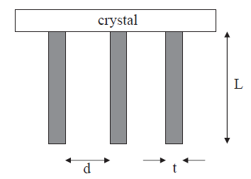

**Figure 4**

(ii) Calculate the septal thickness required for $γ$-rays of 140 keV for lead collimators with a hole diameter of 0.1 cm and a length of 2.5 cm. The attenuation coefficient for lead is 30 ${cm}^{-1}$ at 140 keV.

1. Isosensitive imaging is a technique that acquires nuclear medicine scans from opposite sides of the patient, and then combines the signals to remove the depth dependence of the signal intensity. By considering the attenuation of $γ$-rays in the patient, show how this technique works, and what mathematical processing of the two scans is necessary.

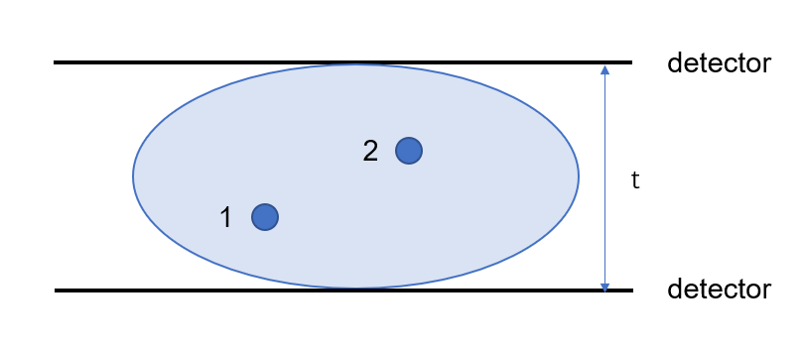

1. What timing resolution would be necessary to obtain a position resolution of 10 mm in TOF PET based only upon time-of-flight considerations?
2. Suggest why a PET/CT scanner operating in 2D mode has a relatively uniform axial sensitivity profile, whereas in 3D mode the sensitivity is much higher at the center of the scanner.